**BME2104 -《生物医学影像技术》Home Work #2**

Due Date: April 17, 2024

***Note:*** *Please prepare your answers to the problems in a single PDF, and upload your PDF to Blackboard.*

* 1. Iodine-based agent is commonly used in X-ray and CT imaging to enhance contrast. Applying the physics principle of X-ray and matter interactions, and if the X-rays are of monochromatic energy at 60 keV, please find the answers to the following:
     1. What is the wavelength and frequency of 60 keV x-ray photon?
     2. What is the relative x-ray absorption ratio of iodine to calcium which is the main element in bone?
     3. What is the K-edge absorption energy of iodine and calcium, respectively?
     4. At 60 keV, which one is the dominant interaction mechanism for total x-ray attenuation, absorption or scattering? Is there any chance of pair production at 60 keV?
     5. When incident X-ray is at 60 keV, how does the energy of Compton scattered x-ray depend on the scattering angle? Write down your equation, and then plot the scattering photon energy versus scattering angle.
  2. The spectrum from an x-ray tube is shown in the following figure. After the x-rays from this tube passed through a water cylinder (see right figure below), please sketch out the two expected x-ray spectra at the two positions (1 & 2). Please label those two spectra on the figure. You can superimpose your sketches onto the existing spectrum figure.

|  |  |
| --- | --- |
|  |  |

* 1. Use the following figure, explain the physics principle of Bremsstrahlung radiation, and how does Bremsstrahlung radiation contribute to the X-ray spectrum of an X-ray tube.

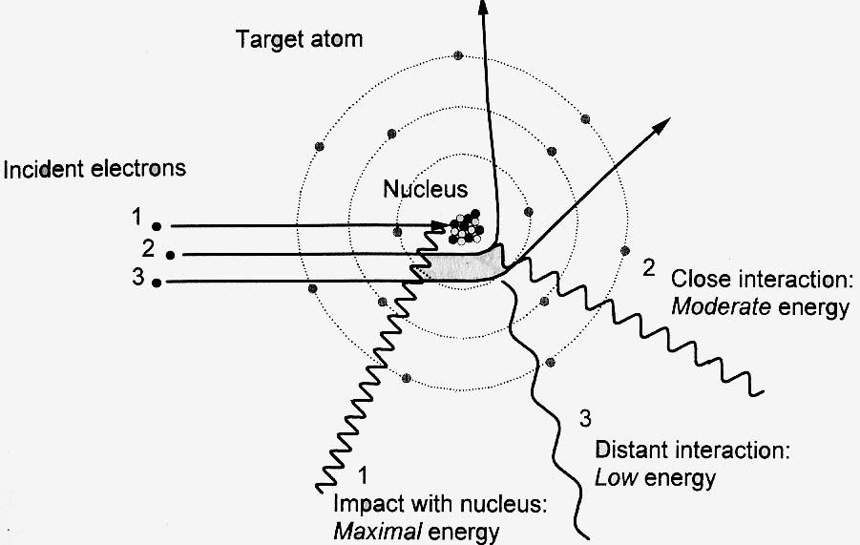

* 1. What is characteristic X-ray of an X-ray tube? Please explain the physics principle behind characteristic X-ray.
  2. Is the following statement correct? Explain why.

Statement: The total Bremsstrahlung output of an x-ray tube depends on both the anode material and the anode voltage.

* 1. Based on the following graph, explain the line focusing principle, focal spot area, and effective focal spot.



* 1. Based on the following graph, explain the cause of anode heel effect in an x-ray tube, and sketch out a possible x-ray intensity curve at the detector that shows the anode heel effect.

